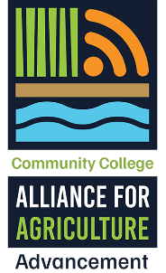
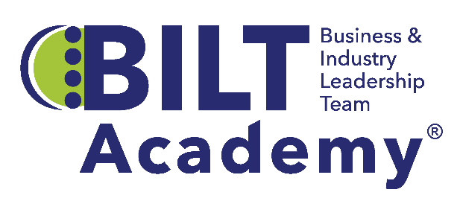


The Business & Industry Leadership Team (BILT) Academy®
2026-27 Academy Requirements and Application

The BILT Academy® is designed to assist community and technical colleges in their efforts to actively engage local business and industry in co-leading college programs through implementation of the Business & Industry Leadership Team (BILT) model. Agriculture programs from two-year colleges are invited to apply to become part the 2026-27 C2A3 Academy Cohort. Information about the BILT model and details of Academy participation follow. Applicants may email hcotner@cord.org with questions about the Academy or application.

Application Due Date and Milestones:
Application Due: September 10, 2026
Applicants Notified: September 25, 2026
Academy Duration: October 2026 – May 2027

What is the BILT Academy?
Led by the Center for Occupational Research and Development’s (CORD) BILT subject matter experts, the BILT Academy® provides cohort-based professional development and one-on-one coaching to assist colleges in implementing and sustaining the BILT model. The BILT model is a proven method for strategic employer engagement developed by Academy Director, Dr. Ann Beheler, and supported by the National Science Foundation for the past two decades. Colleges engaged in the BILT Academy are trained on each step of the BILT Annual Cycle, a clear roadmap that ensures consistent engagement, partnership growth, and program innovation. The Academy training program is designed to develop strong business engagement between technical education programs and the employers who seek to hire their graduates.

What’s So Unique About the BILT Model?
BILT organizes employer engagement around a structured yet flexible co-leadership framework, giving industry a much stronger voice in program design, credential validation, and curriculum development. BILTs convene three times a year to discuss industry trends and desired workforce competencies graduates will need 12-36 months in the future. The Knowledge, Skills, and Abilities (KSA) analysis is an annual curriculum prioritization process during which BILT members individually vote and then discuss as a group the prioritized competencies they believe program curriculum should cover. Faculty compare the resulting priorities with existing and planned courses and modify content to respond to the workforce needs of BILT member companies. The BILT model’s frequency, specificity, and depth of business input, combined with a co-leadership structure, results in clear industry guidance for programs.
Learn more about the BILT model.
Program Format: The BILT Academy® provides cohort-based professional development, one-on-one coaching, and meeting facilitation to assist two-year colleges in building strong and sustainable employer relationships.
Eligibility: Teams from agriculture-related programs at two-year colleges
Cost: No cost for participating colleges

College Commitments:
- Identify a single program, such as horticulture or precision agriculture rather than an entire department or division, to implement the BILT model.
- Participate in five cohort training sessions to support implementation of each step of the BILT Annual Cycle.
- Participate in monthly team calls with a dedicated BILT coach.
- Follow the BILT Annual Cycle of engagement activities.
- Identify one faculty and one administrator to serve as team members. Commit appropriate time to BILT recruitment, collaboration with a coach on the development of pro forma KSAs, and completion of the curriculum cross-reference process in a timely manner.
- Identify an employer who understands the benefits of co-leadership to participate in cohort trainings and monthly coaching calls.
- Create a plan for sustaining and expanding the BILT once the coaching period has ended.

College Benefits:
- Technical assistance from an experienced BILT coach
- Cohort training sessions focused on implementation support
- Tools, templates, and resources for BILT implementation
- Facilitation support for one KSA analysis meeting. The KSA analysis enables colleges to prioritize the knowledge, skills, and abilities (KSAs) employers expect workforce-ready graduates to possess 12-36 months into the future.
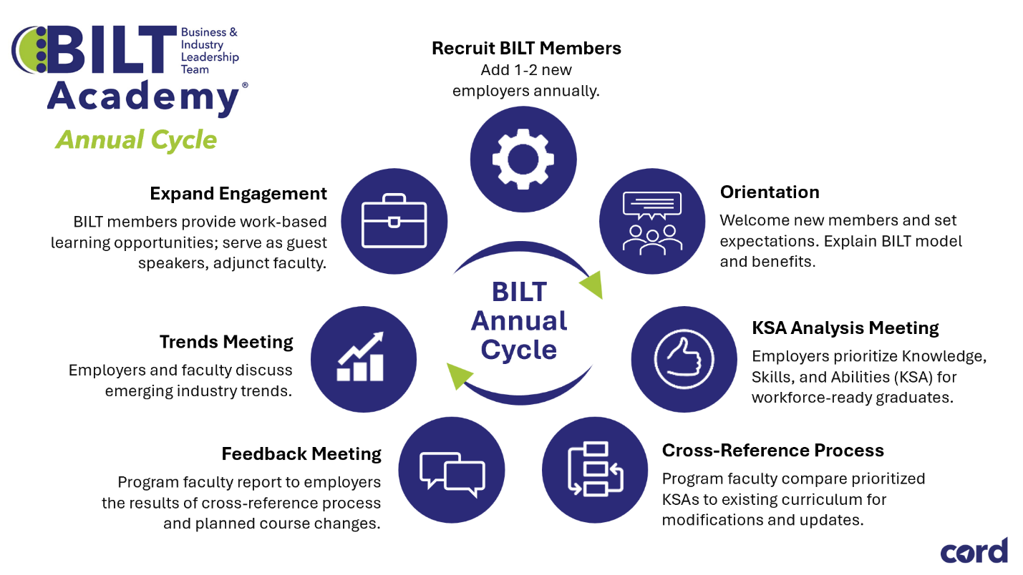

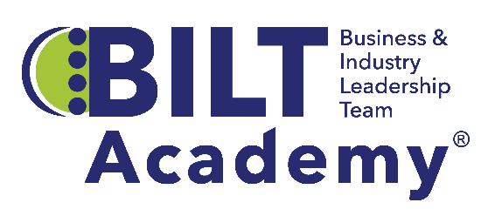
C2A3 Cohort 2026-27 Application
This application should accurately reflect your college’s relevant experiences, planning activities, and desired benefits of participation. All items below must be completed, including the identification of all three team members. Email your application as a Word file on or before September 10, 2026, to BILT@cord.org

Respond to each item in the space provided below; rows will expand as you type. Please be thorough yet concise. We encourage examples where appropriate, but lengthy narratives are not necessary.

Section I: Your Institution and Participating Program

Name of College:
College Website:
Program that will adopt the BILT Model:

Team Members:
Lead Faculty Contact Name:
Title:
Address:
City: State: Zip:
Email: Phone:
Lead Administrator Contact Name:
Title: (Associate Dean or above)
Address:
City: State: Zip:
Email: Phone:
Lead Employer* Contact Name:
Title: Company:
Address:
City: State: Zip:
Email: Phone:

*This individual will be expected to participate in cohort training sessions and monthly coach calls as much as possible.

Current Advisory Committee Members:
Please list current members of the advisory committee for the program area that will be adopting the BILT model. If your program is new, please list potential members. Add rows as needed.
Name | Company | Title | Current Level of Engagement (Low/Medium/High)

Section II: Your Experience
Experience with Employer Engagement
Describe the activities of your current advisory committee, such as including soliciting feedback on curriculum and industry credentials, developing work-based learning opportunities, engaging guest speakers, etc. Also include the number of meetings per year and the average attendance at each.

Section III. Your Partnerships
Identify key partnerships your team will leverage to support BILT adoption. Describe how partners will support recruitment and implementation, and help expand work-based learning opportunities.
Internal Partnerships:

External Partnerships:

Section IV. Motivation and Desired Benefits
What motivated your program/college to pursue adoption of the BILT model?

How could your college team benefit from participation in the BILT Academy?

Institutional Commitment

[Name of College] affirms the proposed BILT Academy Team is committed to active participation in, and completion of all Academy requirements outlined in this application.

Name and Title of College Dean or Vice President

Signature of Named Individual Date

